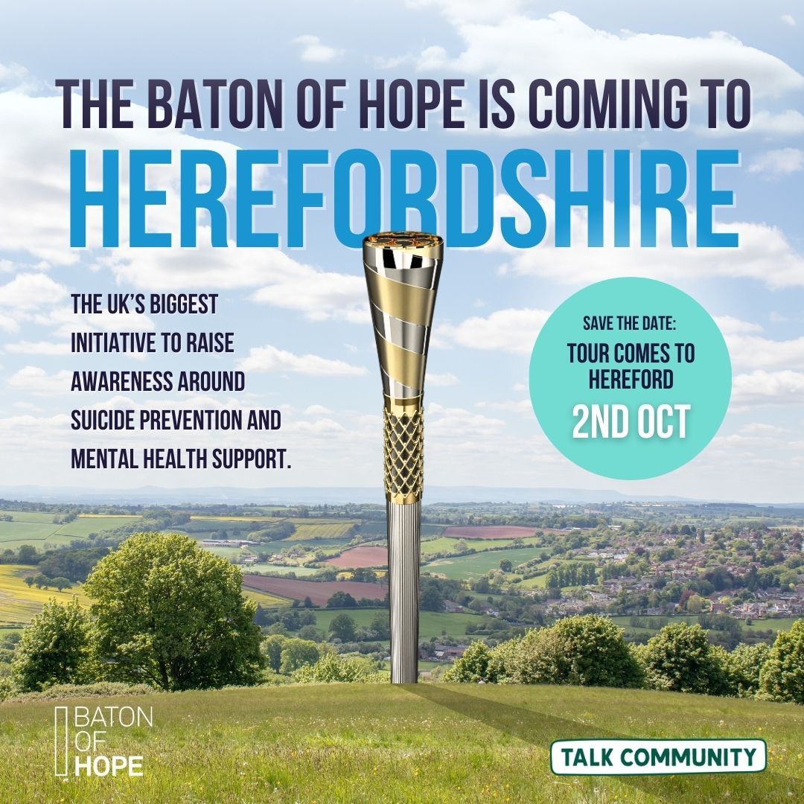

Baton of Hope Connection Grant

Information & application pack

To mark the Baton of Hope coming to Herefordshire, Talk Community is offering small grants of up to £150 to local organisations, groups, and hubs across the county.

Although the baton’s journey will take place through Hereford city, we want the message of hope, connection, and support for mental health to reach every part of Herefordshire—our market towns, rural villages, and communities large and small. This grant is here to help you bring people together in your area, so that everyone can be part of this important moment.

**What is it?**

We want to make it easy for you to bring people together. Whether that’s a simple coffee morning, a pop-up afternoon tea, or something creative in your neighbourhood. Your event doesn’t have to be big. In fact, we know the power of small very well, sometimes the best connections start with a single conversation.

**We particularly welcome ideas like:**

* Coffee mornings, afternoon teas, or drop-in sessions with free refreshments
* Community picnics or lunch clubs
* Arts and crafts activities focused on hope, connection, or mental wellbeing
* Information stands, signposting, or small talks/discussions
* Any gathering that helps people connect, talk, and feel less alone

**Why Conversation Matters**

At the heart of the Baton of Hope is the simple act of talking, encouraging open conversations around mental health, reducing stigma, and making it normal to share how we’re feeling. Sometimes, just listening and being present can make a world of difference.

The Baton of Hope day is about creating supportive communities, whether that’s over a cup of tea, a shared lunch, or any activity that brings people together. Your event is an opportunity to offer more than just refreshments, it’s a chance to create a welcoming space for warmth, connection, and mutual support, helping to reduce loneliness and isolation.

**How it works: 5 Easy Steps**

1. **Chat with us about your idea**

Discuss your proposal with a Talk Community Development Officer. We’ll chat through your idea, offer support if needed, and answer any questions.

1. **Complete the super simple application form**  
   Tell us about your idea and how your get-together will help people connect.
2. **We’ll review your application and confirm your grant**After you apply, we’ll review your idea, offer any support or advice you might need, and let you know if your grant has been approved
3. **Start organising and invite people to join in**  
   Make it meaningful, manageable, and fun for you and your community.
4. **Save your receipts**  
   We’ll pay your grant up front to help you get started. All we ask is that you keep receipts for your spending, these help us show the impact of the grant and keep things simple for everyone.
5. **Enjoy your get-together!**  
   Celebrate, take photos, and let us know how it went.

All funded events will be added to the Talk Community Directory so we can celebrate and share the many ways Herefordshire is coming together for the Baton of Hope.

**Please read the criteria below before you submit an application:**

* **Local:** Your idea must come from a Herefordshire resident, group of residents, or community-based group.
* **Brings people together:** Your event should connect people and/or improve mental wellbeing in your community.
* **Baton of Hope focus:** Your activity should help raise awareness of the Baton of Hope and its message of hope and support.
* **One-off event:** Funding is for a single event—no ongoing or repeat costs can be supported.
* **Event date:** Your activity must take place on **2 October 2025**.
* **Not-for-profit:** All money goes towards making your event happen
* **Inclusive:** Everyone is welcome, and your activity does not promote political or religious beliefs
* **Maximum grant:** Grants are up to £150 per event

**Baton of Hope Connection Grant - Application Form**

*All fields must be completed

|  |
| --- |
| **Project Name:** |
|  |
| **Primary Contact Name:** |
|  |
| **I am/ we are** |
| Informal - Individual resident/volunteer  Informal - Group of residents/volunteers  Formal - formalised less than 3 years ago. Constituted Group, CIC, Registered Charity etc. |
| **Proposed locations/s that your project will take place including postcode (this must be within Herefordshire)** |
|  |
| **What is your idea?** |
|  |
| **How much funding do you need (up to £150 available)** |
|  |
| **What will the funding be used for?** |
|  |
| **How does your idea support the Baton of Hope message?** |
|  |
| **Please provide the name of the geographical neighbourhood or area that will benefit from your project or idea** |
|  |
| **How many people do you expect to take part?** |
|  |
| **Will this grant support any specific community groups?** Please provide (if multiple groups, please add all): (for example, based on sex, carers, those with a disability/long term health condition, ethnic minority groups, LGBTQ+, looked after children or those due to leave care, pregnant or up to a year after birth, refugee/asylum seekers, or religious or faith group) |
|  |
| **Contact Number** |
|  |
| **Email address** |
|  |



All my answers are true and complete to the best of my knowledge



If successful, I will provide information to help evaluate the impact of this grant

|  |
| --- |
| **Fraud statement** |
| By completing the application or accepting the grant, you are confirming that you are eligible for the grant. If your eligibility circumstances change after making an application or receiving this grant, you must notify us immediately. Herefordshire Council will not accept deliberate manipulation or fraud, and any instances will be actively investigated. Any individual who falsifies their records or dishonestly provides inaccurate information to gain a grant will face prosecution. The council reserves the right to recoup funds or grant awarded equipment and claw back any grants given in error. The personal information we have collected from you will be shared with fraud prevention agencies who will use it to prevent fraud and money-laundering and to verify your identity. If fraud is detected, you could be refused certain services, finance, or employment. Further details of how your information will be used by us and these fraud prevention agencies, and your data protection rights, can be found on the Herefordshire Council website here:  [Fraud prevention privacy notice - Privacy notices – Herefordshire Council](https://www.herefordshire.gov.uk/directory-record/6201/fraud-prevention-privacy-notice) |

|  |
| --- |
| **Data Protection** |
| Herefordshire Council is the Data Controller under data protection law for any personal data provided by you and we will only use the information you provide on this form to administer, process and assess your application for funding under the UK Shared Prosperity Fund (UKSPF) Grant Scheme and to administer any funding if your application is successful. The legal basis for processing this data is that it is necessary for the performance of a contract with you or to take steps preparatory to such a contract.  Individuals have a number of rights under data protection law, including the right to request their information. You also have a right to make a complaint about our handling of your personal data to the Information Commissioner’s Office <https://ico.org.uk/>  We will keep your data once an application is approved and funding released for the period of 10 years as defined by the funding body. Information may be shared with other persons or organisations helping us with the assessment and monitoring of applications. Information you provide may also be shared with government departments, agencies and third parties appointed in connection with the administration of this grant. |

|  |
| --- |
| **Declaration** |
| **The signature must be from an individual authorised to sign on behalf of your organisation.** |
| **I/we confirm that I/we have read and understood the Fraud Prevention Notice and confirm that the information contained within this application form is true and accurate** |
| Name: Click or tap here to enter text. Position: Click or tap here to enter text. |
| Signature 1Enter signature Date: Click or tap to enter a date.  Email address: |
| Name: Click or tap here to enter text. Position: Click or tap here to enter text. |



If you would like help to understand this document or would like it in another format or language, please contact the Talk Community team at Herefordshire Council: [talkcommunityenquiries@herefordshire.gov.uk](mailto:talkcommunityenquiries@herefordshire.gov.uk)

We would like projects to be both environmentally and economically sustainable wherever possible and help and advice is available by calling 01432 261930.

**Please submit your application by email to:** [**talkcommunityenquiries@herefordshire.gov.uk**](mailto:talkcommunityenquiries@herefordshire.gov.uk)